EXPERIMENT-35
AIM
To build a K-Means clustering model that segments retail customers based on their spending patterns and visit frequency to identify distinct customer groups.
ALGORITHM
- Import necessary libraries (pandas, sklearn).
- Prepare or load a dataset containing customer IDs, total spending, and visit frequency.
- Select the features for clustering (e.g., total spending, frequency).
- Train a K-Means clustering model with a chosen number of clusters (k).
- Assign each customer to a cluster.
- Display cluster assignments for each customer.
- Optionally, visualize the clusters using a scatter plot.
CODE:
import pandas as pd
import numpy as np
from sklearn.cluster import KMeans
import matplotlib.pyplot as plt

# Sample dataset
data = {
'CustomerID': [101, 102, 103, 104, 105, 106, 107, 108],
'TotalSpent': [500, 1500, 800, 2500, 1200, 3000, 700, 2000],
'VisitFrequency': [5, 15, 7, 25, 12, 30, 6, 20]
}

df = pd.DataFrame(data)

# Features for clustering
X = df[['TotalSpent', 'VisitFrequency']]

# User input for number of clusters
k = int(input("Enter number of clusters (k): "))

# Train K-Means model
kmeans = KMeans(n_clusters=k, random_state=0)
df['Cluster'] = kmeans.fit_predict(X)

print("\n--- Customer Segments ---")
print(df[['CustomerID', 'TotalSpent', 'VisitFrequency', 'Cluster']])

# Optional: visualize clusters
plt.scatter(df['TotalSpent'], df['VisitFrequency'], c=df['Cluster'], cmap='viridis')
plt.xlabel('Total Spent')
plt.ylabel('Visit Frequency')
plt.title('Customer Segmentation')
plt.show()
INPUT:
Enter number of clusters (k): 3
OUTPUT:
--- Customer Segments ---
 | CustomerID | TotalSpent |  | VisitFrequency |  | Cluster
0 | 101 | 500 |  | 5 |  | 2
1 | 102 | 1500 |  | 15 |  | 0
2 | 103 | 800 |  | 7 |  | 2
3 | 104 | 2500 |  | 25 |  | 1
4 | 105 | 1200 |  | 12 |  | 0
5 | 106 | 3000 |  | 30 |  | 1
6 | 107 | 700 |  | 6 |  | 2
7 | 108 |  | 2000 |  | 20 | 0
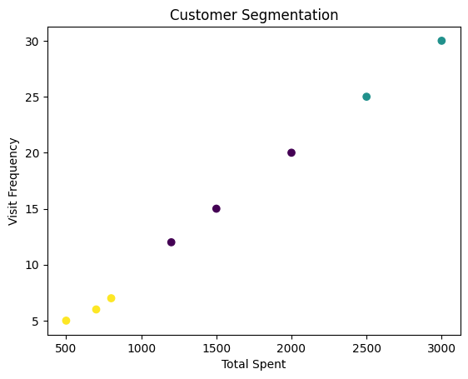
RESULT
The K-Means model successfully grouped customers into segments based on their spending and visit frequency.
This segmentation helps the company tailor marketing strategies for different customer groups.

